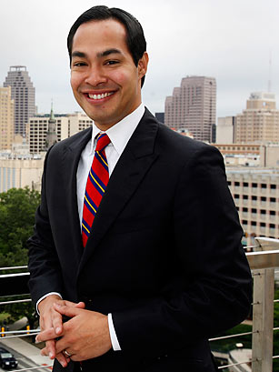a

captain progress

A User-friendly MS Word Poster Template

Mayor of San Antonio, TX

Supreme Court Justice

President of the United States

Julian Castro

Ruth Bader Ginsburg

ACS is centered around the idea that the law should be a force to improve the lives of all people. By bringing together powerful, relevant ideas and passionate, talented people, ACS makes a difference in the constitutional, legal and public policy debates that shape our democracy.

Barack Obama

**tnh 2.38**

**September 28th**

**12:00 PM**



*Lunch Provided*