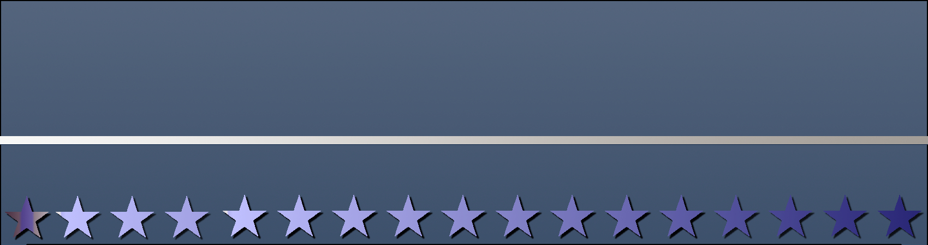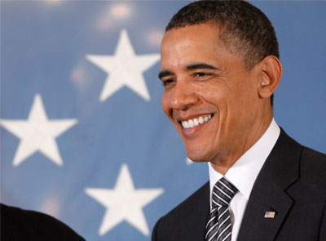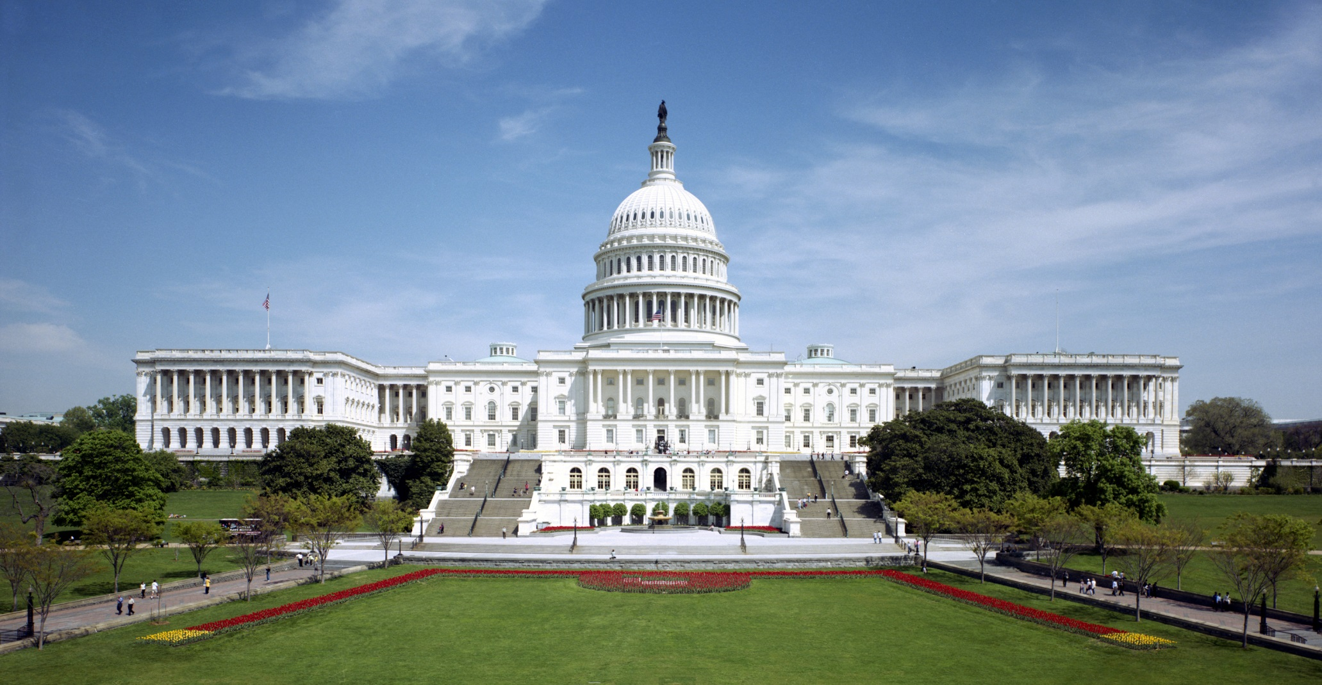

Barack Obama

Barack Obama is the 44th and current president of the United States. He attended Harvard University Law School where he was president of the law review. He was a community organizer in Chicago before earning his law degree. He worked as a civil rights attorney in Chicago and taught constitutional law at the University of Chicago Law School from 1992 to 2004.

*Lunch Provided*

ACS is centered around the idea that the law should be a force to improve the lives of all people. It works for positive change by shaping debate on vitally important legal and constitutional issues through development and promotion of high-impact ideas to opinion leaders and the media. By bringing together powerful, relevant ideas and passionate, talented people, ACS makes a difference in the constitutional, legal and public policy debates that shape our democracy.

**tnh 2.38**

**September 28th**

**12:00 PM**

A User-friendly MS Word Poster Template

captain progress