Politics & Policy

A Decision That Will Live in Infamy
It will take generations for the Supreme Court to live down its approval of Trump’s travel ban.
By
Noah Feldman
June 26, 2018, 9:28 AM PDT
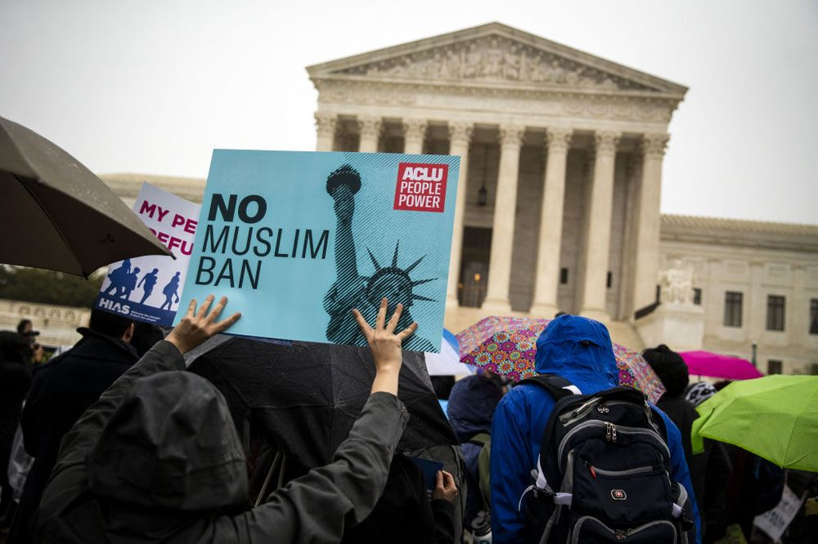
They lost — and so did America.
Photographer: Bloomberg/Bloomberg
Noah Feldman is a Bloomberg Opinion columnist. He is a professor of law at Harvard University and was a clerk to U.S. Supreme Court Justice David Souter. His books include “The Three Lives of James Madison: Genius, Partisan, President.”
In what may be the worst decision since the infamous Korematsu case, when the Supreme Court upheld the internment of Japanese-Americans during World War II, the court today by a 5-4 vote upheld President Donald Trump’s Muslim travel ban.
Like the Korematsu decision, Trump v. Hawaii elevates legal formalities as a way to avoid addressing what everyone understood is really at issue here — namely, prejudice. Chief Justice John Roberts’s majority opinion downplays Trump’s anti-Muslim bias, focusing instead on the president’s legal power to block immigration in the name of national security.
The decision will be a stain not only on the legacy of the Roberts court, but on that of the Supreme Court itself. The court tried to compensate by saying how bad the Korematsu decision was. And Justice Anthony Kennedy wrote a separate concurrence in which he hints that perhaps the lower courts could reconsider the question of anti-religious animus. But these efforts are far too little to save the court, or Kennedy, from the judgment of history, which will be harsh.
Roberts’s opinion focuses mostly on the Immigration and Nationality Act, which gives the president the authority to exclude foreigners if he finds that their entry “would be detrimental to the interests of the United States.” Yet to focus on Roberts's analysis would be to make the same crucial error as Roberts himself — that is, treating one of the most outrageous acts of presidential bias in modern U.S. history as though it were an ordinary exercise of presidential power, taken by an ordinary president acting in good conscience.
When Roberts comes to the topic of bias, he recounts Trump’s anti-Muslim statements and the history of the travel ban (this is the administration’s third version). Then he balks. “The issue before us is not whether to denounce the statements,” Roberts writes. Rather, Roberts insists, the court’s focus must be on “the significance of those statements in reviewing a presidential directive, neutral on its face, addressing the matter within the core of executive responsibility.”
That is lawyer-speak for saying that, despite its obviousness, the court would ignore Trump’s anti-Muslim bias. Roberts is trying to argue that, when a president is acting within his executive authority, the court should defer to what the president says his intention is, no matter the underlying reality.
That’s more or less what the Supreme Court did in the Korematsu case. There, Justice Hugo Black, a Franklin D. Roosevelt loyalist, denied that the orders requiring the internment of Japanese-Americans were based on racial prejudice. The dissenters, especially Justice Frank Murphy, pointed out that this was preposterous.
Justice Sonia Sotomayor, the court’s most liberal member, played the truth-telling role today. Her dissent, joined by Justice Ruth Bader Ginsburg, states bluntly that a reasonable observer looking at the record would conclude that the ban was “motivated by anti-Muslim animus.”
She properly invokes the Korematsu case — in which, she points out, the government also claimed a national security rationale when it was really relying on stereotypes. And she concludes that “our Constitution demands, and our country deserves, a Judiciary willing to hold the coordinate branches to account when they defy our most sacred legal commitments.”
The pragmatist Justice Stephen Breyer was joined by his fellow pragmatist, Justice Elena Kagan, in a more cautious dissent focused on the system of exemptions that the executive order permits. If those exemptions were to be used, Breyer writes, it would lend some credence to the idea that the ban was actually motivated by national security. One can imagine that Breyer hopes the travel ban won’t really be enforced in practice, and so wants to encourage the exemptions to be used.
Unfortunately, the wrongness of the travel ban lies as much in its symbolic effect as in its exclusion of people from five Muslim-majority countries. This wasn’t the right case for Breyer and Kagan to be quite so pragmatic.
And maybe Breyer also doesn’t want to alienate Kennedy, whose votes the liberals will need on future issues if he does not resign this summer. But Kennedy has joined conservative decision after conservative decision this term; pragmatic efforts to win him over seem to have failed.
Kennedy’s concurrence betrays his own bad conscience. He writes that the lower court could still consider whether it was proper to look for religious animus “in light of the substantial deference” due to the president. And because the case was before the Supreme Court as the result of a preliminary injunction, not after a trial, it is still theoretically possible for the lower courts to hold a trial to consider further evidence of presidential bias.
The problem is that evidence of Trump’s bias has already been presented — and found insufficient by the justices. Without some significant new piece of evidence, it’s hard to see how a lower court could find that the order was actually motivated by anti-Muslim animus.
Kennedy was trying to fashion a fig leaf for himself. But his efforts failed, and the nakedness of his selling out his own jurisprudence of animus should be clear to all.
Roberts certainly knows the consequences of this decision. He tries to deflect the Korematsu comparison by saying that the order as written could have been enacted by any other president — a point that is irrelevant to the reality of the ban. Roberts also takes the opportunity to announce that Korematsu “was gravely wrong the day it was decided [and] has been overruled in the court of history.”
In another context, we might well be celebrating the fact that the Supreme Court had finally and expressly repudiated Korematsu, which it had never fully done before. Instead, Roberts’s declaration reads like a desperate attempt to change the subject. The truth is that this decision and Korematsu are a pair: Prominent instances where the Supreme Court abdicated its claim to moral leadership.
It has taken two generations for the court to begin to live down the taint of Korematsu. The taint of Trump v. Hawaii will last just as long.

