The First Amendment & Free Speech
Elementary School

Description: This unit introduces students to the Supreme Court’s decision in Tinker v. Des Moines Independent Community School District, 393 U.S. 503 (1969), which established that school officials could not punish or prohibit student speech unless that speech will result in a substantial disruption of school activities or invades the rights of others.

Objectives: (1) Familiarize students with the facts of Tinker v. Des Moines; (2) Introduce them to the concept of free speech; and (3) Leave them with an appreciation and respect for the Constitution and the Bill of Rights.

Lesson Length: 45-60 minutes

Age Group: 1st Grade – 5th Grade

About Constitution in the Classroom

Lawyers, law students, and educators have a valuable resource to share with students: knowledge and appreciation of the Constitution. Constitution in the Classroom brings ACS members into high school, middle school or elementary classrooms to raise awareness of fundamental constitutional principles and excite young minds about their constitutional rights and responsibilities.

About the American Constitution Society for Law and Policy
The American Constitution Society (ACS) believes that law should be a force to improve the lives of all people. ACS works for positive change by shaping debate on vitally important legal and constitutional issues through development and promotion of high-impact ideas to opinion leaders and the media; by building networks of lawyers, law students, judges and policymakers dedicated to those ideas; and by countering the activist conservative legal movement that has sought to erode our enduring constitutional values. By bringing together powerful, relevant ideas and passionate, talented people, ACS makes a difference in the constitutional, legal and public policy debates that shape our democracy.

The Tinker Case: Students Taking a Stand
Mary Beth Tinker went to school in Des Moines, Michigan, in the 1960s. At the time, the United States was at war in Vietnam. Mary Beth, her brother, John, and their friends wanted to show everyone that they wanted the war to end. To show how they felt, they made black arm-bands and wore them to school. A couple of other students asked them why they were wearing the arm-bands, and some of those kids did not agree with their opinions, but nobody got into any fights. The school told Mary Beth and the other students to go home until they agreed to take off the arm-bands, and they were suspended for several weeks.
The students’ families thought that it was wrong to punish people for having strong political views, so they went to court. The case went all the way up to the United States Supreme Court, the highest court in the country. On February 24, 1969, the Supreme Court said that Mary Beth was right—she should not have been suspended because all she did was peacefully show her opinion, and her right to express her opinion was protected by the First Amendment to the United States Constitution.

Constitutional Basics
When our country first began, our Founding Fathers got together and decided to write a set of rules for running the new government. They met in Philadelphia, Pennsylvania, in 1797 and wrote a set of rules about how Congress, the President, and the States should work. They called it the United States Constitution.
What are some other types of rules you know about? Guide the students to understand the similarity between rules for our government and the rules for games and classroom behavior.
Q:
After the Founding Fathers wrote rules for the government, then they realized something was missing: rules for the people! So they went back to work and added 10 more rules, or amendments, to fix the Constitution. These 10 rules make up what is called the Bill of Rights and they make sure the government could not get carried away and stop people from having the freedom to live their lives. (Remember, that’s the whole reason people came to live in America – because they thought the King of England was taking away their freedoms.) The first new rule in the Bill of Rights is called the First Amendment and it helped protect Mary Beth. Let’s see how.
The Five Freedoms
- Religion
- Speech
- Press
- Assemble
- Petition the Government

Understanding the First Amendment
The First Amendment protects five freedoms, or important things that every citizen must be allowed to do. These “Five Freedoms” include freedoms of religion, speech, press, assembly, and the right to petition the government. Today we’re going to talk about the freedom of speech, which allowed John, Chris, and Mary Beth to wear their arm-bands at school.

Discussion
What does it mean when a person has “rights?” The government cannot force you to do something or stop you from doing something. (This does not apply to your friends and family.)
Q:
Each of the Five Freedoms protects an important right:
- The freedom of religion tells the government that it cannot force you to believe in one particular religion or stop you from practicing your religion;
- The freedom of speech means that the government cannot stop you from speaking your mind or tell you what to say;
- The freedom of the press means that newspapers, magazines, and TV stations can report the news and say what they want without government censorship;
- The freedom of assembly means that the government cannot stop you from having a meeting with your friends; and
- The freedom to petition the government means that you have the right to tell your representative in Congress if you think the law is unfair or should be changed.
Do kids have any rights? If so, do they have all the same rights as adults? Yes, kids have rights, but they do not have all the rights adults have.
Q:
For instance, they have the right to wear something that shows their viewpoint without disrupting their classroom. However, they do not have some rights adults have, like the rights to vote or run for President.
Which of the Five Freedoms protected Mary Beth? Why is that freedom so important? The freedom of speech protected Mary. It is important because that is how we let our government officials know if they are doing a bad job and how we speak out and change bad laws.
Q:
How can we call what Mary Beth did “speech” if she did not say anything out loud? Speech means conveying a message—and there are lots of ways to tell people how you feel without actually saying anything out loud.
Q:
When the Founding Fathers wrote “speech” in the Bill of Rights, they meant all types of communication. Back in those days, there were no phones, TVs, or internet. When the Founding Fathers were alive, people had to communicate either by talking or by printing flyers and handouts and giving them out on the streets.
Other examples of ways you can communicate without actually speaking include: painting a picture, putting a sticker on your car, putting a sign in your yard, writing a letter to the newspaper, or making a movie.
If we have freedom of speech, does that mean you get to say anything you want, anywhere and anytime you want? No, there are still some rules.
Q:
For instance, if you are in a government building, like a public school or City Hall, you cannot be disruptive. That means that you cannot threaten people or pick fights with people. But if you’re on somebody’s private property (such as a friend’s house or a store), then the people who own that building are the ones who get to make the rules. If they don’t like what you say or how you say it, then they can ask you to leave.

ACTIVITY

Identifying Your Right To Speak
At the end of this lesson plan you will find four images of public and private spaces. This exercise is designed to apply the rules the students just learned about the freedom of speech to real-world situations.
For each image, ask the students the following series of questions:
- Would this be a proper place for a person to give a speech or hand out flyers?
Why or why not?
- What problems might come up if somebody tried to give a speech here?
- What if somebody who hears you speaking doesn’t agree with you? Does that mean they can call the police and make you stop talking?
  - No, that’s why we have freedom of speech— because not everyone agrees with everyone’s opinion, and it’s OK to say something other people disagree with. When America first started out, not everyone agreed with becoming an independent country, but aren’t we glad that the people who supported independence were allowed to speak?
- So if I can give a speech in the park or on the sidewalk, does that mean I can put up a great big billboard and just leave it there?
  - No, the government can always regulate the WAY you speak to stop you from stepping on other people’s rights, and if you put up a billboard, that might stop other people from using the park or the sidewalk.

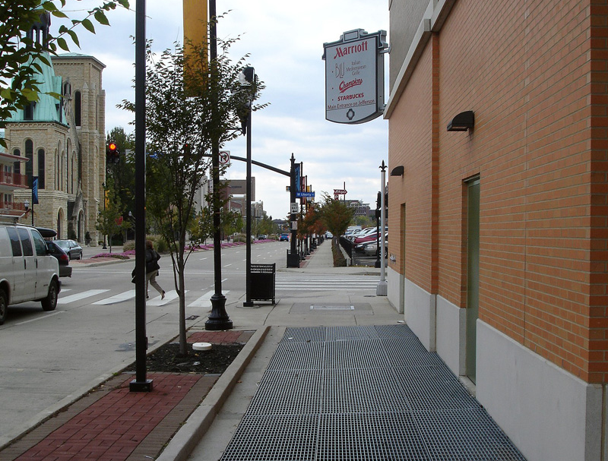
ON THE SIDEWALK?
INSIDE THE LIBRARY?
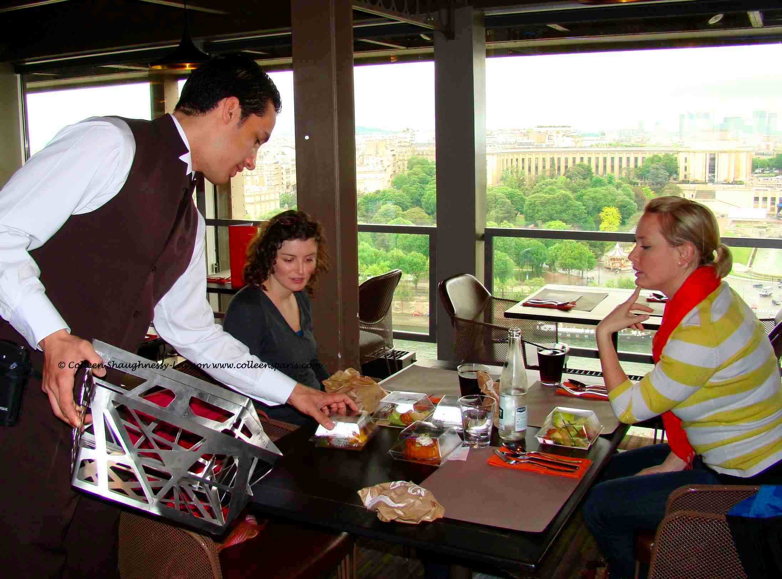
INSIDE A RESTAURANT?
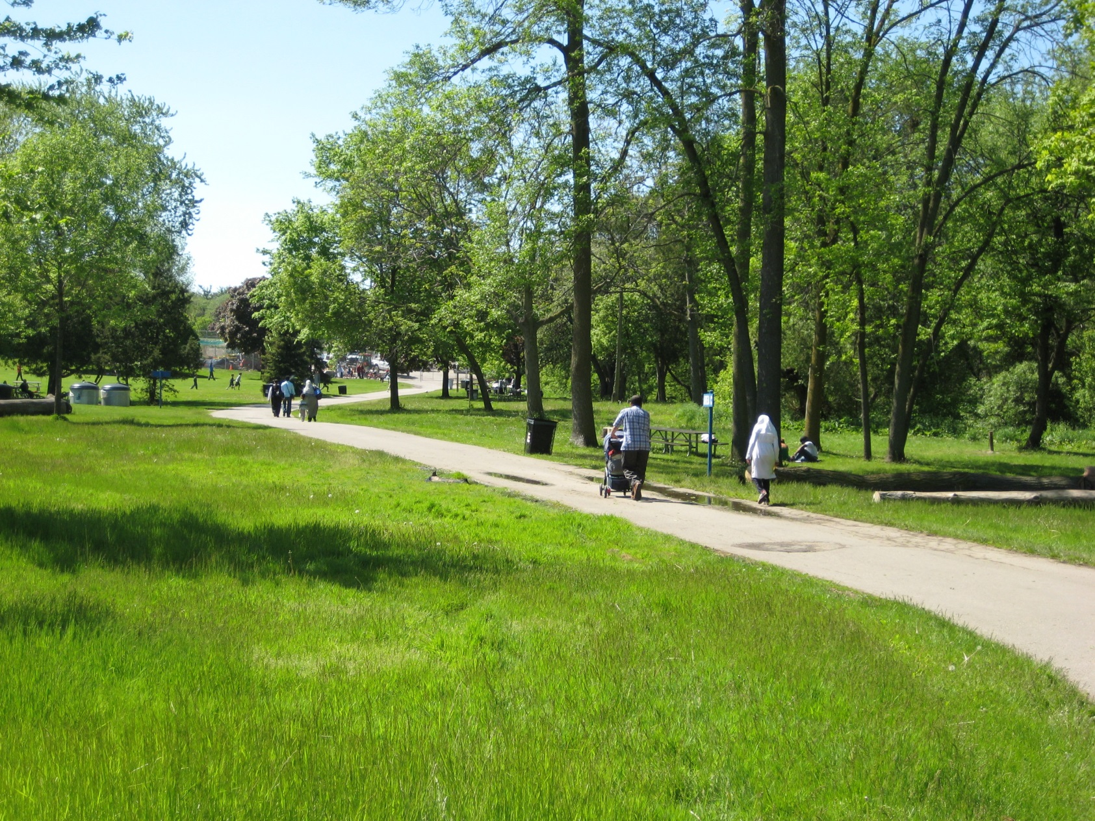
AT THE PARK?

